**Text Mining**

**Extracting Reviews from Snapdeal-FULL HD TV**

**Word cloud**

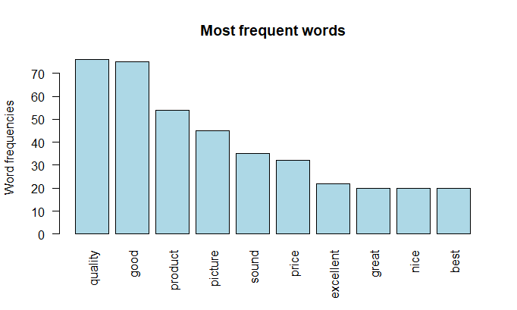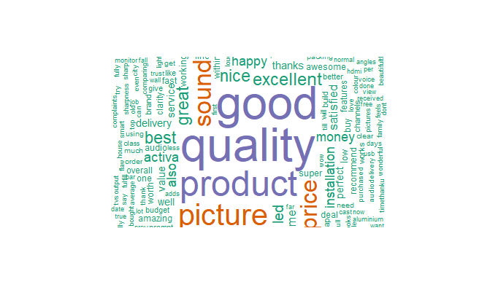

**From above plot and word cloud, we can say that full HD TV of active brand is good quality product with sound and picture quality.**